Developing a Unit-Testing Framework for Biological Mechanistic Models
Individual Research Project (IRP) Year 4 Brighton Sussex Medical School 2026/27
Oliver Fields - Supervised by Simon Mitchell

IRP Progress Log
- W/C Monday 21st September 2026
GitHub Repo created: https://github.com/OliverAFields/bie-parser-schema
Comments generated for the baseline High vs Low BCR notebook.
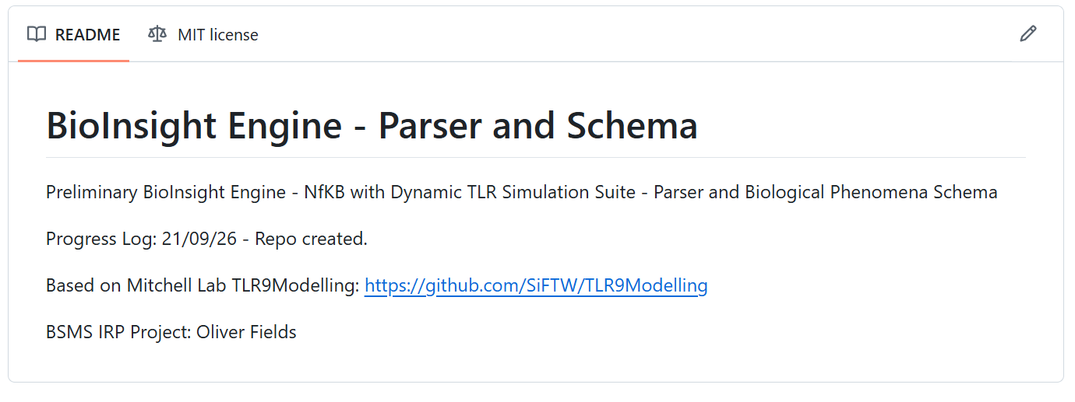
Generated biological flow diagram for the baseline Tri-Model Shared TAK1 pool
- See Appendix 1
Altered baseline model to run on windows with current packages. Change log:
File | Change | Reason
runSimulation.jl | Removed syms=Symbol.(syms) from four solver-function calls | Keyword removed in SciMLBase 3. Species names are still attached when results are saved, so outputs are unchanged.
runSimulation.jl + notebook | using DelayDiffEq; explicit MethodOfSteps(Rodas5P()) for both solves | DifferentialEquations 8 no longer bundles or auto-selects a delay-equation solver.
defineInputs.jl | Guard added to the CpG pulse shape function g(s) | ForwardDiff 1.x produced a NaN derivative at t = 0, which aborted every time course. Values are identical to the original.
plotAllSpeciesNew.jl | * replaced in output filenames | Windows does not allow * in filenames.
generateModel.jl | python3 → python | Windows command name.
Generated first outputs with baseline model using the existing repo setup for high BCR input vs low BCR input with varying CpG pulses and height over 24 hours (15 cells, runtime 4m 53s):
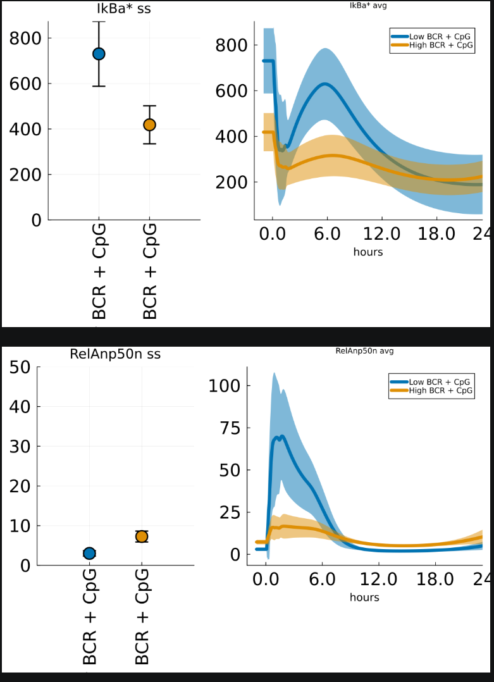

- Simon Mitchell added to GitHub repo and approved initial model run and flow diagram.

- W/C Monday 28th September 2026

Initial Schema Drafted and iterating.

Meeting with Hasnain (Other IRP member – Biological phenomena focus) to discuss schema draft.

- W/C Monday 5th October 2026

Initial Schema finalised V0.5
- See BIE-Initial-Schema-Oct-2026.docx

Parser Drafted and Dummy Schema setup.

Appendix 1: Generated BCR-NFKB-TLR9 Flow Diagram
Generated using Claude Opus 5; Full artifact available at: modelFlowDiagram.html
- The complete model is not in such human readable format, the only plausible way to display the model without immense time and expert knowledge is AI.
